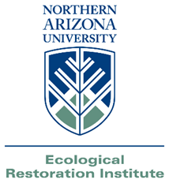
Outreach Notice
Seasonal Ecological Research Technicians
Ecological Restoration Institute
Northern Arizona University
Flagstaff, AZ

The Ecological Restoration Institute (ERI) at Northern Arizona University in Flagstaff is nationally recognized for mobilizing the unique assets of a university to help solve the problem of unnaturally severe wildfire and degraded forest health throughout the American West. The ERI collaborates with land management agencies and communities by providing comprehensive focused studies, monitoring and evaluation research, and technical support. The mission of ERI is to serve as an objective leader in research, scholarship, and education, and in collaborative efforts to plan and implement restoration treatments for frequent-fire forest and woodland landscapes of the West.

The ERI is hiring seasonal field technicians for the 2014 summer field season, with the specialties listed below, to assist with research on forest restoration and ecosystem health projects. Crews will be working in the high elevation coniferous forests of Arizona and possibly other locations and ecosystems. This is a full-time, 40 hours per week position for the duration of the field season. Work consists of 10-hour days during the summer, from May 12th until August 21st (15 weeks). Local work in the vicinity of Flagstaff will be in the form of 4-day weeks, from Monday through Thursday, with three-day weekends off. Out-of-town work typically consists of 8-day trips (Thursday-Thursday). All three positions will require working in remote backcountry settings with diverse groups of people under potentially adverse field conditions. Candidates must have a valid driver’s license and be able to frequently travel away from Flagstaff (up to 20 days per month) for fieldwork.

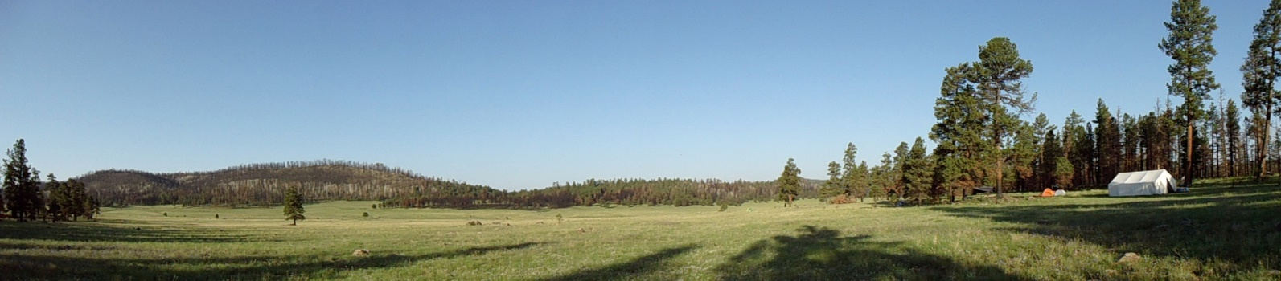
Forestry Technicians
- Description: Forestry technicians will utilize a variety of methods to measure forest attributes such as tree height, diameter, and condition class; tree regeneration; shrub abundance; and surface fuels. Technicians will use digital cameras to document plot conditions and hand-held computers to enter and error-check data.
- Desired Qualifications: Prior experience in forest tree and stand measurements and field research, preferably in the western United States; experience with ecological restoration research projects; experience with field computers and electronic data collection is desirable.
Field Botanists
- Description: Field botanists are expected to know or quickly learn the flora of southwestern forests to maximize data collection quality and efficiency. Methods include collecting cover and richness data on vegetation quadrats, point-line intercept transects, and belt transects. Field botanists may also collect data on forest structure and fuels as needed.
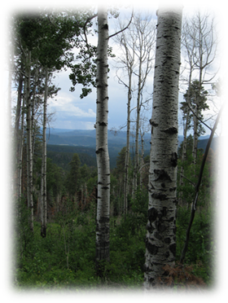
- Desired Qualifications: Prior experience in plant community measurements and plant identification, preferably in the western United States or working with ecological restoration research projects. Experience in keying plants or a taxonomy course. Experience with field computers and electronic data collection methods is desirable.
Crew Leaders
- Description: Crew leaders must have qualifications and experience befitting the forest technician and/or field botanist positions above, and will be expected to utilize their additional experience to lead crews of other technicians and ensure the efficient and safe collection of high-quality data without direct daily supervision.
- Desired Qualifications: Prior experience in forest measurements and field research, preferably in the western United States; prior experience on ecological restoration research projects. Experience with electronic data collection methods and conducting quality control routines. Experience leading field research crews. GPS and field navigational skills. Wilderness first aid/WFR training is desirable.

Physical Demands
These positions require crew members to work in isolated and rugged environments at elevations ranging from approximately 5,000-9,500 feet. They also require work in potentially difficult field conditions (steep slopes, rain, lightning, venomous reptiles, etc.). Field gear will need to be carried across rugged terrain, in addition to a personal daypack. Applicants should be prepared physically and have the appropriate clothing and gear to work and camp in these environments.

Salary
$13-17.00/hr., depending on position and experience. Subject to funding.

Application Deadline
Open until filled.

Interested/Questions
Contact Walker Chancellor at (928) 523-7284 or Walker.Chancellor@nau.edu for additional details or if you have questions concerning this position.

How to Apply
Please send a resume and cover letter indicating the position for which you are applying to:

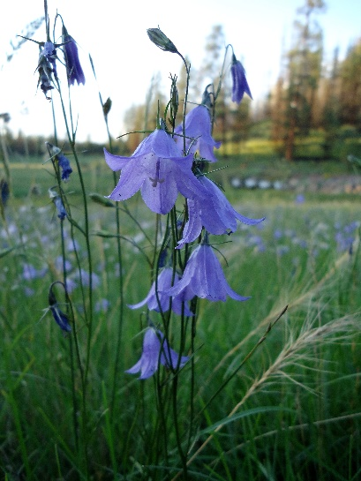
Walker Chancellor, Ecological Restoration Institute, Northern Arizona University, P.O. Box 15017, Flagstaff, AZ 86011; walker.chancellor@nau.edu.

